Aggregate query = a formula for calculating SUM, AVG, etc.

Using AS = changing a name from “formula” to a name

HAVING = using the formula name to apply the condition to the group value instead of the single row

COUNT = function that count id where the type name is listed multiple times.

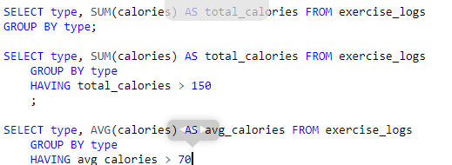

Software Engineers:

The software engineers would use SQL to communicate on the server-side with the database that's storing all of the user's data. They would need to figure out how to insert data and update it (which we'll discuss much later)

Data Scientist:

They are the ones analyzing the data, trying to learn more about users, maybe coming up with suggestions about how to help them exercise more. They need a deep understanding of SELECT statements, because they need to do very complex queries to do the analysis they're interested in.

Product management:

They are the decision makers at a company, the people that look at the data, talk to users, look at the market, and try to understand how to improve a product to get more users, make users happier, or make more money. They often need an understanding of SQL queries so they can look at usage statistics and try to understand what parts of a product are being used the most, which parts are being used in surprising ways, and what isn't being used at all.

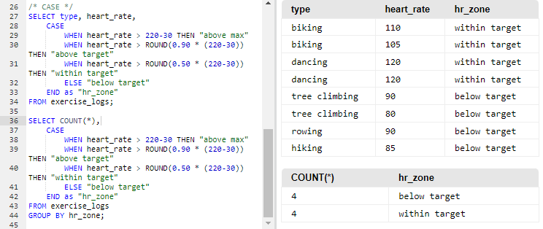

**STATEMENTS:**

CASE => Similar to “IF/SWITCH” in programming. Allows to create a new column and label the data.

END as => Is placed at the end of the CASE statement and allows you to label the new column

**CONDITIONS:**

WHEN/ELSE => used to describe the condition in a CASE statement

**EXPRESSION:**

THEN => used as a sting of text to label data in a condition

Track

Grades

Column = Names, Number grade, and % of activities completed

Show

,

(59,'The Hunger Games: Mockingjay - Part

1','LGF',752.10,337.10,0.45,415.00,0.55,2014),

(60,'X-Men: Days of Future Past','Fox',748.10,233.90,0.31,514.20,0.69,2014),

(61,'Madagascar 3: Europes Most

Wanted','P/DW',746.90,216.40,0.29,530.50,0.71,2012),

(62,'The Chronicles of Narnia: The Lion, the Witch and the

Wardrobe','BV',745.00,291.70,0.39,453.30,0.61,2005),

(63,'Monsters University','BV',743.60,268.50,0.36,475.10,0.64,2013),

(64,'The Matrix Reloaded','WB',742.10,281.60,0.38,460.60,0.62,2003),

(65,'Up','BV',731.30,293.00,0.40,438.30,0.60,2009),

,

(48,'E.T.: The Extra-Terrestrial','Uni.',792.90,435.10,0.55,357.80,0.45,1982),

(49,'Fast & Furious 6','Uni.',788.70,238.70,0.30,550.00,0.70,2013),

(50,'Indiana Jones and the Kingdom of the Crystal Skull','Par.',786.60,317.10,0.40,469.50,0.60,2008),

(51,'Spider-Man 2','Sony',783.80,373.60,0.48,410.20,0.52,2004),

(52,'Star Wars','Fox',775.40,461.00,0.60,314.40,0.41,1977),

(53,'Guardians of the Galaxy','BV',774.20,333.20,0.43,441.00,0.57,2014),

(54,'2012','Sony',769.70,166.10,0.22,603.60,0.78,2009),

(55,'Maleficent','BV',758.40,241.40,0.32,517.00,0.68,2014),

(56,'The Da Vinci Code','Sony',758.20,217.50,0.29,540.70,0.71,2006),

(57,'The Amazing Spider-Man','Sony',757.90,262.00,0.35,495.90,0.65,2012),

(58,'Shrek Forever After','P/DW',752.60,238.70,0.32,513.90,0.68,2010),

(66,'Gravity','WB',716.40,274.10,0.38,442.30,0.62,2013),

(67,'Captain America: The Winter Soldier','BV',714.80,259.80,0.36,455.00,0.64,2014),

(68,'The Twilight Saga: Breaking Dawn Part 1','Sum.',712.20,281.30,0.40,430.90,0.61,2011),

(69,'The Twilight Saga: New Moon','Sum.',709.80,296.60,0.42,413.20,0.58,2009),

(70,'Transformers','P/DW',709.70,319.20,0.45,390.50,0.55,2007),

(71,'The Amazing Spider-Man 2','Sony',709.00,202.90,0.29,506.10,0.71,2014),

(72,'Dawn of the Planet of the Apes','Fox',708.80,208.50,0.29,500.30,0.71,2014),

(73,'The Twilight Saga: Eclipse','Sum.',698.50,300.50,0.43,398.00,0.57,2010),

(74,'Mission: Impossible - Ghost Protocol','Par.',694.70,209.40,0.30,485.30,0.70,2011),

(75,'The Hunger Games','LGF',691.20,408.00,0.59,283.20,0.41,2012),

(76,'Forrest Gump','Par.',677.90,330.30,0.49,347.70,0.51,1994),

(77,'The Sixth Sense','BV',672.80,293.50,0.44,379.30,0.56,1999),

(78,'Interstellar','Par.',672.70,188.00,0.28,484.70,0.72,2014),

(79,'Man of Steel','WB',668.00,291.00,0.44,377.00,0.56,2013),

(80,'Kung Fu Panda 2','P/DW',665.70,165.20,0.25,500.40,0.75,2011),

(81,'Ice Age: The Meltdown','Fox',660.90,195.30,0.30,465.60,0.70,2006),

(82,'Pirates of the Caribbean: The Curse of the Black Pearl','BV',654.30,305.40,0.47,348.90,0.53,2003),

(83,'Big Hero 6','BV',652.00,222.40,0.34,429.60,0.66,2014),

(84,'Star Wars Episode II - Attack of the Clones','Fox',649.40,310.70,0.48,338.70,0.52,2002),

(85,'Thor: The Dark World','BV',644.80,206.40,0.32,438.40,0.68,2013),

(86,'Kung Fu Panda','P/DW',631.70,215.40,0.34,416.30,0.66,2008),

(87,'The Incredibles','BV',631.40,261.40,0.41,370.00,0.59,2004),

(88,'Fast Five','Uni.',626.10,209.80,0.34,416.30,0.67,2011),

(89,'Hancock','Sony',624.40,227.90,0.37,396.40,0.64,2008),

(90,'MIB 3','Sony',624.00,179.00,0.29,445.00,0.71,2012),

(91,'Iron Man 2','Par.',623.90,312.40,0.50,311.50,0.50,2010),

(92,'Ratatouille','BV',623.70,206.40,0.33,417.30,0.67,2007),

(93,'How to Train Your Dragon 2','Fox',618.90,177.00,0.29,441.90,0.71,2014),

(94,'The Lost World: Jurassic Park','Uni.',618.60,229.10,0.37,389.60,0.63,1997),

(95,'The Passion of the Christ','NM',611.90,370.80,0.61,241.10,0.39,2004),

(96,'Mamma Mia!','Uni.',609.80,144.10,0.24,465.70,0.76,2008),

(97,'Life of Pi','Fox',609.00,125.00,0.21,484.00,0.80,2012),

(98,'Madagascar: Escape 2 Africa','P/DW',603.90,180.00,0.30,423.90,0.70,2008),

(99,'Casino Royale','Sony',599.00,167.40,0.28, 431.60,0.72,2006)

(100,'Tangled','BV',591.80,200.80,0.34,391.00,0.66,2010)